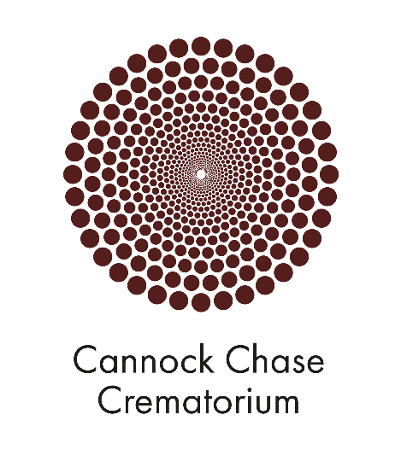

Horizon Cremation
Cannock Chase Crematorium
Environmental Management Statement

Introduction

This document outlines the environmental policies developed by Horizon that will be followed in the operation of Cannock Chase Crematorium.
The management and staff at Horizon aim to limit the impact of our operations upon the environment as we build and operate new crematoria.
We are conscious that cremation is an inherently green activity from the perspective of managing our carbon footprints. Mike Berners-Lee found, when commissioned to assess the carbon footprint of different funeral types in 2016, that cremation is the most carbon neutral form of funeral. This is largely because there is likely to be a crematorium near to where you live which means less travel by mourners and because traditional burial builds in 50 years of carbon costs surrounding the tending and maintenance of a grave.
Simply by opening our facility at Cannock Chase and bringing a new crematorium within easy reach of people not currently well served, Horizon is, therefore, having a positive impact on the environment.
Of course, this is not enough. We want to ensure that in its day-to-day operations the crematorium at Cannock Chase operates in an environmentally responsible manner. At Cannock Chase, we have the advantage of being able to implement policies and operating procedures developed in our first crematorium at the Clyde Coast and, also, to develop new approaches relevant to the circumstances of the Cannock Chase facility.
Our environmental management practices include:
- Seeking to improve our environmental performance
- Ensuring that we meet environmental standards and that our staff understand and work toward upholding those standards.
- Assessing all new policies and activities against tests of their effect on the environment
- Ensuring that our staff and suppliers are aware of their responsibilities for helping us meet these standards.
This document sets out the policies we have developed, the methods we intend to use at Cannock Chase to implement those policies and how we will continue to look for ways to improve performance over time.

Energy Use

Our aims Are:
- To minimise fuel consumption, while functioning in the appropriate manner expected by visitors and our staff.
- To use renewable energy sources where we can. Where this is not possible, to offset the carbon impact of the energy we use.
- To operate our buildings in an energy efficient manner.

At Cannock we will put in place the following working arrangements to achieve these aims.
- Fuel for the cremators is LPG. Where possible, we purchase fuel on a tariff whereby the carbon impact of the gas used is offset by the gas supplier through activities such as tree planting. We will be using such a tariff at Cannock Chase.
- We operate our cremators efficiently to minimise fuel use while still ensuring that emission standards are met. Where possible, we avoid allowing a cremator to cool between cremations to avoid having to heat a cooling machine back to operating temperature.
- The cremators’ fuel consumption and overall efficiency are closely monitored by Horizon staff and by the staff of Matthews Environmental Solutions (Matthews), our cremator suppliers.
- Cremators are serviced by Matthews at the recommended service intervals.
- Heat from the cremators is captured and used to heat the crematorium building and provide hot water.
- Modern insulation and energy efficient methods have been used in the design and building of the facility.
- Electricity in the building is, in part, provided by solar panels mounted on the roof. In situations where the panels generate surplus electricity, this is sold into the grid.

We will monitor outputs from each of these measures (gas usage, electricity generation and usage) on a monthly basis. Significant issues will be addressed straight away but we will review how improvements can be made to our environmental performance on an annual basis.

Water Use

Our aims are:
- To minimise the amount of water used in our operations.
- To maximise sustainable drainage.

We have put in place the following working arrangements to meet these aims:
- Water usage is monitored.
- Tap restrictors are provided in public toilets and staff facilities. We operate low flush toilets, restricting water flow to cisterns
- We will re-use run off water. Captured rainwater is used to irrigating plants and flowers.
- External hard surfaces are kept to a minimum. Car parks, for instance are porous rather than metalled to reduce water run-off.
- Run off rain-water is all led to a natural water source rather than the sewage system.

Water usage will be monitored on a monthly basis. Significant issues will be addressed straight away but we will review how improvements can be made to our performance on an annual basis.

Air Quality

Our aims are:
- To ensure that the facility operates within the requirements of current pollution control legislation.
- To exceed the legal emission requirements whenever possible.
- To maximise good air quality.

We have put in place the following working arrangements to meet these aims:
- The most modern cremators have been installed along with an efficient abatement system to ensure that emissions are scrubbed.
- Emissions from the cremators will be monitored in real time and records kept of the outputs to the atmosphere.
- All cremator operators will be trained and have passed qualifications administered by the Federation of Burial and Cremation Authorities (FBCA). In addition, they will have been trained in the proper operations of the machinery by representatives of the cremator supplier, Matthews.
- Cremators will be serviced by authorised personnel from Matthews at the recommended service intervals.
- We will encourage people to travel to the facility by means other than the car (see Transport).

Emissions from cremators will be monitored continually while they are operating and any issues dealt with immediately. In addition, we will submit evidence of emissions to the local authority as part of its monitoring regime.

Transport

Our aims are:
- To provide facilities that allow members of the public to travel to our site using modes of transport other than the car.
- To reduce the amount of travelling during business hours by our staff and encourage them to use modes of transport other than the car.
- Provide infrastructure allowing the public and our staff to use the most environmentally- friendly forms of car.

We have put in place the following working arrangements to meet this aim:
- A Travel Plan has been prepared and forms part of the planning conditions associated with the building.
- The crematorium is well located for local public transport. We are providing a dedicated and lit pathway through the site from the bus stop on Norton Road.
- Cycle racks are provided close to the building.
- Electric car charging points have been provided to the rear of the car park.
- The website for the crematorium will publicise local bus routes and train connections for member of the public visiting the site.
- Staff are encouraged where possible to leave the car at home when travelling to and from work.
- Meetings and reviews between crematorium staff and Horizon head office are conducted as far as possible by telephone or using tools such as Microsoft Teams and Zoom.

Waste Management

Our aim is:
- To reduce the amount of waste sent to landfill.

We have put in place the following working arrangements to meet this aim:
- We promote waste minimisation, re-use and recycling by staff. Waste paper is recycled, as will be old or redundant computer and audio visual equipment.
- Biodegradable waste will be composted and used in our gardens. This includes composting flowers and floral tributes left at the site and garden waste.
- The waste reagent from the cremator filtration system, often referred to as APCR (Air Pollution Control Residue), is classed as hazardous waste due to it containing mercury and, arguably, represents the largest proportion of waste generated by the process. This waste is collected by Future Industrial Services who take the residue to their facility. They recover the metals (mercury) from the residue for re-cycling and the residual ash, meeting current requirements for landfill, is disposed of. The reclaimed mercury is 99.99% pure.”

Ecology

Our aims are:
- To understand the ecology on the site.
- To take steps to provide habitats that will protect existing species and encourage new ones.

We have put in place the following working arrangements to meet these aims:
- A full ecological survey of the site was conducted as part of the planning process and has been used to inform the landscape design and management plan.
- The majority of the site is being left untouched by development. The habitats of the existing species have been left undisturbed but will be actively managed in the future to encourage existing and new species.
- New trees will be planted on the site, but not to the extent of undermining the valuable grasslands that exist on site.
- We will plant on the site use native species where appropriate.
- We will minimise the amount of pesticides used in the formal memorial gardens.

Noise

Our aims are:
- To reduce noise generated on site so as not to disturb neighbours or wildlife.

We have put in place the following working arrangements to meet this aim:
- External plant and equipment will be well maintained and used correctly.
- We are some distance from neighbouring properties but staff will nonetheless, be trained to ensure that we are sympathetic to neighbours.

Purchasing Decisions

Our aim is:
- To implement procurement decisions that take environmental best practise into account

We have put in place the following working arrangements to meet this aim:
- Wherever possible, items purchased for the crematorium are constructed from renewable or re-cycled materials.
- Wherever possible, items manufactured for the crematorium are purchased from local suppliers to minimise transport costs and allow us to invest in the communities we serve.
- We encourage suppliers to use best-practise techniques when supplying materials.

“How Bad Are Bananas: the Carbon footprint of Everything” Mike Berners Lee. Profile Books 2020

